

NCICB

NCICB


caCORE SDK
Writable API – Backwards Compatibility

Version No: 0.2
Last Modified: 12/12/2008

Author: Satish Patel
Team: caCORE SDK
Client: National Cancer Institute - Center for Bioinformatics,
National Institutes of Health,
US Department of Health and Human Services

This document was prepared for
NCI Center for Bioinformatics, pursuant to the caCORE Software Development Kit (SDK)
Enhancement project.(REF: Solicitation No. S06-234).
Document History

Revision History
Version Number | Revision Date | Author | Summary of Changes
0.1 | 12/12/08 | Satish Patel | Initial draft
0.2 | 12/12/08 | Satish Patel

Review
Name | Team/Role | Version | Date Reviewed | Reviewer Comments
Dave Hau | Engineering Manager | 0.1 | 12/12/08

Related Documents
More information can be found in the following related documents:

Document Name
Contents
1 Introduction 3
2 Proposed Change 3
2.1 Sample code to use new Façade 3
3 Known Limitations (Potential Backwards Compatibility Issues not addressed in this proposal) 3

Introduction

The SDK 4.1 generated writable API is implemented as an extension to the SDK’s core read API aka ApplicationService. The implementation of the SDK 4.1 writable API is not fully backwards compatible with the previous release of the SDK due to the method signature mismatch between the major releases. In order to minimize the upgrade impact for consumers of applications generated with the previous release of the SDK, a unified service interface is needed which resembles the previous interface of the writable API.
Following are the four methods that were present in SDK 3.2.x as part of the ApplicationService interface which are not present in the SDK 4.1 implementation of the writable API
public Object createObject(Object object)
public Object updateObject(Object object)
public void removeObject(Object object)
public List getObjects(Object object)

Proposed Change

In order to meet the requirements of backwards compatibility at the interface level, SDK team will include a façade which mimics the old application service interface for the writable methods as depicted in the diagram below.
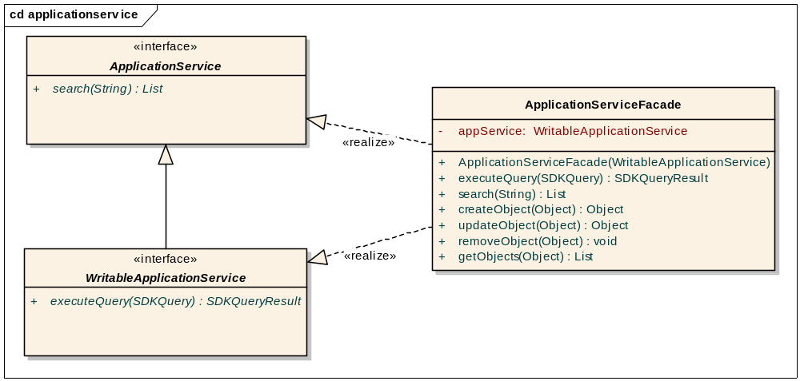
Note: Not all methods of the ApplicationService and WritableApplicationService interfaces are shown here in the diagram but they will be part of the final implementation of this proposed solution.
As shown in the diagram above, the ApplicationServiceFacade class will include the methods needed for the writable api based on the interface definition of the ApplicationService in SDK 3.x. In addition, it will also include all of the methods of the existing (SDK 4.1) ApplicationService interface and WritableApplicationService interface. This approach will allow users to access all methods from SDK 3.x and SDK 4.x including the writable API from a single class.

Sample code to use new Façade
WritableApplicationService newService =
(WritableApplicationService) ApplicationServiceProvider.getApplicationService()
ApplicationServiceFacade oldService = new ApplicationServiceFacade(newService);
Patient patient = oldService.createObject(new Patient());
patient = oldService.updateObject(patient);
oldService.removeObject(patient);

Known Limitations (Potential Backwards Compatibility Issues not addressed in this proposal)

- In SDK 3.x, the ApplicationService class was an abstract class. This class used to contain four methods to instantiate itself from the factory. These methods will not be made available as part of the proposed solution.
ApplicationService.java

public static ApplicationService getRemoteInstance()
public static ApplicationService getRemoteInstance(String)
public static ApplicationService getLocalInstance()
public static ApplicationService getInstance()

- In the SDK 3.x, the ClientSession class was used to log the user in the SDK generated secured application. SDK 4.x does not carry this class anymore. The users are now required to pass their username and password to the ApplicationServiceProvider (factory) while obtaining handle to the Application Service. The methods for the ClientSession class were as given below.
ClientSession.java
public static ClientSession getInstance()
public static ClientSession getInstance(String)
public static ClientSession
getInstance(ApplicationServiceProxy)
public boolean startSession(String, String)
public void terminateSession()
public String getSessionKey()

